

Name: PREMAHLATHA D/O RAMASAMY

Login ID: premahlatha@oasis-portal.com

Course title: Executive Diploma in Business and Hospitality

Management

Subject Code: BHM01

Submitted date: 05 JUN 2017

**Table of Contents**

|  |  |  |
| --- | --- | --- |
| No | Details | Page |
| 1 | Executive Summary | 2 |
| 2 | Introduction | 3-4 |
| 3 | Assignment Question |  |
|  | Part 1 | 5-6 |
|  | Part 2 | 7-8 |
|  | Part 3 | 9 |
|  | Part 4 | 10 |
| 4 | Conclusion | 11 |
| 5 | References | 12-13 |
|  | Appendix | 14-16 |

**Executive Summary**

In this assignment, I’m able to understand the Human Resources Management(HRM) within a Hospitality Management operations. A HRM department is an organization that plays it role as a medium between tri-parties which are company, employees and the community (customers) to strengthen the bond between those parties to achieve the goal of the hospitality industry.

Firstly, I defined the HRM with relating to recruit, compensation, hiring, performance management, organizational development, safety, health, benefits, employee motivation, communication, administration, and training where these are the major activities to build the connection between hospitality industry and employees.

Furthermore, I studied about the Human Resources Planning and Planning Trend in Hospitality. In this part, I’m explaining about the responsibility for Human Resources Planning and how to formulate the HR plans.

Next, briefing about Human Resources Functions and Human Resources Policies in Hotel Industry are included in this assignment.

Finally, I’m also explained about what is organizational behavior in Hospitality and how it impacts in term of individuals, groups and structure in an organization.

**Introduction**

Human Resource Management (HRM or HR) *is a comprehensive program of business administration.* (**Assignment,2017**). This assignment explained about the contribution of Human Resources Management in Business and Hospitality Management. Nowadays there are many job vacancies for HR position where it’s reportedly that not necessary to know all about this field. It just, the person who want to be in HRM must have an excellent communication skills and must be flexible to handle any situation especially problem arises among employees. Yet, the truth is, it’s not that easy to be a HR because HRM department really need to add real business value to their organizations. So, the organization will and should hire the correct officer to this position.

Why the HRM is that so important in all industry? The answer is the human resource management provides a key support function within an organization. As a solid example, all section even a front office or the customer service in any industry must have the direct connection with HR because the director of HR can distribute application forms and other personnel-related information to job applicants. Human resource management exists to ensure organizations have the right people who will be able to achieve the organizational objectives. Especially in the hotel business, which has good, qualified and hardworking manpower will distinguish between the good and the bad of the hotel. Due to of this, human resource being integral and notable part of the hospitality industry where they able to cover almost all the legal aspect of the hotel.

The main activities of HR are recruit new staffs to company and trained them well for the overall better performance. This is the part where the HR should make the exact decision in choosing staff because the *HR department is responsible for hiring new employees and newly hired employees can seriously affect the performance of the hotel which makes it necessary for managers to employ the best and most qualified workers in the present market by following the appropriate hiring process, in which each candidate is critically assessed and only those which have hard work being hired*. (**The Write Pass Journal, 2012**). There are some candidates thought that being work at hotel is “piece of cake”, as they think that there is nothing else to do, however hotel services require proactive employees who can decide decision on time and can clear all the customer’s doubt with their solo performance. Not only recruit, but the terms which have connection with employees like selecting, hiring, training, motivation, evaluation, safety & health and compensation also included in major activities of this HR specialists.

These activities connected to each other, just like after recruit the new candidates, the HR need to select the candidates who passes in various rounds which available in the process of selection. Those who have passed the exam will hired by the company. On their training day, the candidates must learn about the job skills as On-Job-Training (OJT) and they will provide with some motivation from HRM in reason of encouraging the candidates to work to their full potential. Next, HRM will evaluate the performance of the candidate whether they can make it self-improve or not within short period because the candidate who can learn faster the programs and skills in workplace will have a better compensation compared to other workers. Yet the candidate should make their HRM satisfied with their performance due to the compensation that available for them will calculate and distribute by these specialists. The HRM department also must responsible to their worker’s safety, health and welfare, where in their first meeting with employees, they should distribute the insurance policy which they arrange mainly for the workers. The bigger the company, the bigger the duty of HRM.

The importance of understanding the difference in culture is significant to every sector of business including hospitality industry. This is the only one distinctive industry where the consumer being brought to the product instead of taking the product to consumer. It doesn’t matter about the size of the company is small or large, the organization (not only the HRM department) should be bold and energetic to meet a need or to pursue collective goals.

**Assignment Questions**

**Question 1**

Define the Major Activities and Human Resources Operation in Hospitality Management. (20 Marks)

As we know, Human Resources Management(HRM) is a key role in helping companies to find quality employees to achieve the future goals. *Human resource management (HRM) is the governance of an organization’s employees. HRM is sometimes referred to simply as human resources (HR). A company’s human resources department is responsible for creating, implementing and/or overseeing policies governing employee behavior and the behavior of the company toward its employees.* (**Human Resources Management, August 2011**). This HR management is a vital part in hospitality industry due to these specialists enables the staffs to contribute effectively and increase the productivity of this industry. And this is also a group which have links to all section in hospitality management including servers, housekeepers, porters, kitchen workers, bartenders, management, marketing, facility maintenances and front office.

Human Resources specialists are very familiar with skills on recruiting and selecting employees in an organization. Firstly, recruitment and selection is the processes where finding and hiring suitable people for job vacancies based on certain criteria. The steps involve in these processes are such as making decision to recruit new employee, conduct job analysis, source for applicants, collect information on applicant, select most suitable applicant, offer employment to successful applicant and hold induction once employee reports for duty. For instance, the candidates who attend the interview section basically will questioned for about 4 to 5 questions regarding the company’s SWOT and the one who answered smartly will be their (HRM) choices to the jobs.

Next, training and development is the official and ongoing educational activities within an organization designed to enhance the fulfillment and performance of employees. This section’s aim is for familiarizes the employees with their jobs at their workplace. Mostly, the staffs will be trained on job etiquette, personal grooming, time management, ethics and so on. For example, one common thing in all industry is, the newly welcomed staff or worker will be squeezed to work under pressure (mostly interns). The purpose of doing it is to estimate the patience of the staff because this is the one of the quality that should have within every staff. This is also categories under one of the training tricks so that the staff can understand what and how should handle problem in any situation.

Furthermore, the staff must try to develop her or his skills equally to the hospitality industry’s requirement. The HRM will evaluate the best performers so that they can work in a better environment for a better position and income. The evaluation is the assessment and review of a worker's job performance. Mostly all the industry will be evaluated the employees when newly arrived and once in a year to ensure the organizational goals can be achieved at the specified time. The promotion that given to a staff by HRM depending on the staff’s performance and self-improvement in relation to the achievement of the company is an example of evaluation in a company.

Moreover, the motivation given to an employee will be done by HRM to boost them and bring confident on doing their work. A motivation defined as internal and external factor that stimulate the desire and energy to be directly interested in the people and committed to the task, role or subject, or to try to achieve the company goal. Every hotel has distributed guest card to each guest to allow them to give their comment on specific departments or staffs. So, if a guest praised our staff, pay the bonuses to that staff. This motivated the staff and they will try to improve their interaction with guest next time.

Also, the most likeable part in company for a staff is compensation. Compensation is the combination of money and other bonus, commission or rewards that an employee receives for doing their job from employer. The compensation included with the extra benefits like festival bonus, medical facility, food and transport allowance and accommodation facility where the company give their main priority to staff and make sure all facilities are obtained by the staffs. Did we know that the HRM specialist are the one who responsible for this part? How does we get overtime(OT), annual leave approval and so on? Yes, they are the one who play their role as next line manager to conduct this program.

In conclusion, the HRM management have link with every operation in a hospitality industry such as front office, housekeeping, food & beverages and security maintenance. As we know, the customer will encounter first the front office in hospitality industry and the purpose of this department is to send information about the customer to other department within the company. So, in this case HRM won’t have any direct contact with the customer but they will receive the information by this front office staffs because they trained the staff as this position will come in direct contact with customer the most. This is an example that explained how the HRM have contacts with other department in a company.

**Question 2**

Describe in brief on Human Resources Planning and Planning Trend in Hospitality.

Explain about what is your understanding on Action Plan Human Resources Planning in Hotel Industry. (20 marks)

In searching for what’s meant by Human Resource Planning (HRP), it is a process that the human resources identify the present and future needs for an organization to achieve its goals. *Human resource planning should serve as a link between human resource management and strategic planning of the entire organization. Aging of the working population in many western countries and the growing demand for qualified workers in developing countries have stressed the importance of effective human resource planning.* (**Wikipedia,2017**). In a simple rhyming, it is a strategic plan with 6R which is to ensure **Right number and Right kind of people at Right time at Right place to do the Right job and to do the job Right.** The main aim of this plan is to fill the correct number of employees to a job, with matching skills to chip in gain the company goals. Other objectives of HRP is ensuring enough supply of manpower to a company and try to predict the future requirements for human resources skills. And planning on how placing the new technology in job and requirements for human resources also one of HRP is objective. *According to Sikula “the ultimate purpose / objective of human resource planning is to relate future human resources to future enterprise need to maximize the future return on investment in human resources”.* (**Your Article Library, Smriti Chand**)

The Human Resources Planning Trend in Hospitality Management are assessing HR, demand forecasting, supply forecasting, matching demand & supply and action plan Human Resources Planning in Hotel Industry. In detail, assessment in industry is an evaluation made on a person or property. At the Hotel Industry, this plan is vital to ensure the staff’s performance on providing high-quality, efficient service and benefits to an applicant or candidate. This plan is also useful to assess HR department includes evaluating processes, procedures and staff qualifications. Example of this plan is, preparing a schedule for meeting staff in human resources to discuss about current situation so that can update any new programs. What is demand forecasting? It is the estimating of the future human resources’ requirement at right quality and right number. This forecasting human resources demand is depending on several factors such as employment trend, replacement needs, productivity, absenteeism & turnover and expansion & growth of the company. Next about supply forecasting, *it is an essential in determining the characteristic of hiring source within the predetermined planning horizon to establish whether future HR supply is sufficient to match future HR demands.* (**Slide share, 2014**). For instance, there are 2 types of future source in this part where one of it is internal source (promotion, transfer) and other is external source (recruitment of new candidates). Matching demand and supply is relating to the carrying forecast future demand and supply matching process HR. They refer to bring supply and demand into balance so that the position and office staff shortage will be solved. Action plan is the last part in human resources planning which is concerned with surplus and shortages of human resource. Action plans or major activities are recruiting, selecting, training, motivating, socialization where every time need to update to check whether the HRP is matches with HR objectives.

Next, as mentioned earlier the action plans are recruiting, selecting, training, motivating etc. But, how the Human Resources Planning(HRP) in Hotel Industry contributes in this action plan? First, in recruitment plan the HRP will make decision in which work need more employees and they will fill the correct number of employees in that work. In Hotel Industry, most of the job vacancy will open to customer service because it is the only one work where need too many staffs to work to improve the customer service. Second, retention plan where keeps the old staffs who have 30 to 50 years work experience in reason to be a buddy trainer to newly coming employees. This type of plan always executes in Hotel Industry especially in housekeeping management to teach the skills to the new staffs. Furthermore, training plan also will have provided in all industry to make sure the new candidates can learn and catch with the job scope. In Hotel Industry, there are some time will give to new staffs to pick up the tricks and skills in their given work in purpose of can decrease the mistakes in work. In addition, redundancy plan is also included in HRP. In this process, all unwanted people or extra worker or the workers who can’t improve their self in work will be terminated. Such as, in Hotel Industry the staffs should flexible to any situation but there some staffs can’t be flexible and this might be a reason for the company to terminate the staff because they want to achieve their goals by the staffs who can be adopt to any environment. Finally, productivity also in HRP because with increase the productivity, they can provide systematic framework and structure to an organization and can increase the profitability. As a prove, *if overall hotel productivity is measured through revenue per worked hours, simply outsourcing certain service departments will boost productivity, as the absolute number of hours worked within a hotel’s team will decrease. However, it can very well be that outsourcing increases the cost base of the hotel, which will outweigh the benefits of the increased productivity. Only if the company to which the services are outsourced can deliver the services in a more effective manner than hotel employees (usually due specialization), and these increases in efficiency are partly reflected in the prices charged to the hotel, will the net benefits to the hotel be positive.* (**Hospitality Net,2008**)

**Question 3**

Brief about Human Resources Functions and Human Resources Policies.

Describes the Functions of Management and How the policy applies accordingly in Hospitality Management. (20 marks)

The Human Resources(HR) functions are recruitment, safety, employee relation, compensation & benefits, and training. As mentioned earlier, the HR will recruit the worker who have self-confident and talent because they want to fill the correct amount of worker to the suitable works. Next, the safety and health of worker is the responsibility of HR as they know the workplace, the employees and their work demands. As it outlined in company’s policies and program, they must ensure the employees fulfill their safety and health responsibilities every time when the in workplace. More, employee relation is also HR’s function in an organization. Any rules regarding performance, conduct, conflict of interest and discipline of all employees must be take note by HR who also play their role as next line manager. This will help the HR by managing the improper behavior of employees to make a productive workplace. Even a HR try to conduct a good relationship with their employees, but not smart in the matter of compensation and rewards, there are some problems will arise among HR and employees. This is due to money matter can even separate blood relation, in that case how about the organization and employees? So, HR should give an extra focus in this part to calculate the compensation that should every employee get the equal amount or fair rewards. Training is also one of HR’s function where the lesson that they teach to the new employee must be correct and eligible to their status. If the employees got wrong information about the job scope, then it’s meant HR should be the one who responsible to the situation.

What is Human Resources Policies? A policy is a formal rules and guidelines on the approach an organization in purpose of adopting managing its people. Procedures are one of it where it contains a clear communication between the organization and their employees regarding their condition of employment. It also includes with the context for supervisor training programs and employee orientation programs. Other than that, legal issue is also includes in this policy. Legal issue is about the working hour, overtime(OT), all type of leaves etc. For example, if an employee wants to apply for a sick leave or annual leave, before 2 weeks he must apply for it and should be approve by our HR. This is a common rule in all company. Additionally, organizational structure also a phase in this policy. *A structured policy can help organizations run more effectively and provide members of the organization of information and understanding of the formal structure of the organization. The basic structure of an effective organization should apply to every department of the organization. In addition, to maximize the effectiveness, organizations need to enable both the management and staff for creating basic organizational structure of the organization.* (Small Business Chron, Brian Bass).

This both Functions of Management and Human Resources Policies applied strongly in Hospitality Management.

**Question 4**

Explain in detail about Organizational Behavior in Hospitality and brief on Groups and Structure in Organization. (20 marks)

The Organizational Behavior(OB) is defined as the interaction of people within a large group to create an efficient business organization. It’s also a study of human behavior in organizational settings, the interface between human behavior the organization, and the organization itself.

This study propose is to learn how people react into a group towards improving an organization’s effectiveness. The importance of OB is, OB can help in predict what people will do under different situations by research. It’s also chip in by understanding the individual’s fashion and upgrade them whenever it needed. The motivation that given in very company where it helps managers to managing the employees is under OB.

The basic concept of studying OB is to answer our assumptions on human behavior. For example, is that we can predict the age barrier to learn? Does that experience make a man perfect? A company’s productivity is due to of productive worker or happiness leads to productivity? All this question will have answered in OB. OB also can play its role in enhancing leadership and decision-making skills. The contribution of OB in management skills such as motivating, creating, listening, communicating etc. is very high.

So, the OB on group and structure is very simple. A group defined two or more individuals who need cooperate to each other to achieve objectives. Companies mostly prefer the employees to work in group because they easily can gain power or skills on job so that can increase the productivity of the company.

Next, organizational structure defines how tasks are divided, grouped, and coordinated the organization. Each organization has a structure that describes the role of the members of the organization implement, so that everyone understands their responsibilities to society. There are six elements in organizational structure; work specialization, departmentalization, chain of command, span of control, centralization & decentralization and formalization which contribute on how the tasks are carried out in an organization.

**Conclusion**

It can be seen the contribution of HRM in all industry especially in hospitality industry. This can be seen in main actions of HRM which are recruiting, selecting, training, motivation and compensation where their involvement in those action are to increase the productivity of hospitality industry. The point of Human Resources Management(HRM) is to make sure fit the right staff in human resource so that the quality will be maintained in this management. The well experienced HR must hard work to bring up the company with hired all the capable staff into the company so that both side (company and employee) can get the equal benefits.

**References**

1)Assignment. (2017) (Online) Human Resources Management- An Introduction.

Retrieved from:

<http://www.assignmenthelp.net/assignment_help/human-resource-management-an-introduction>

2)The Write Pass Journal. (November 16,2012) (Online) Human Resources Management in The Hospitality Industry.

Retrieved from:

<https://writepass.com/journal/2012/11/human-resource-management/>

3)Search CIO. (August,2011) (Online) Human Resources Management (Definition).

Retrieved from:

<http://searchcio.techtarget.com/definition/human-resource-management-HRM>

4) Wikipedia. (2017) (Online) Human Resources Planning.

Retrieved from:

<https://en.wikipedia.org/wiki/Strategic_human_resource_planning>

5)Your Article Library. (Smriti Chand) (Online) Human Resource Planning: Objectives, Need, Importance and Levels.

Retrieved from:

<http://www.yourarticlelibrary.com/human-resources/human-resource-planning-objectives-need-importance-and-levels/35237/>

6)Slide Share. (2014) (Online) HR Supply Forecasting.

Retrieved from:

<https://www.slideshare.net/sajnafathima988/hr-supply-forecasting>

7)Hospitality Net. (2008) (Online) Productivity Management in the Hospitality Industry

Retrieved from: <https://www.hospitalitynet.org/opinion/4035884.html>

8)Small Business Chron. (Brian Bass) (Online) Organizational Structure Policies.

Retrieved from:

<http://smallbusiness.chron.com/organizational-structure-policies-14617.html>

**Appendix**

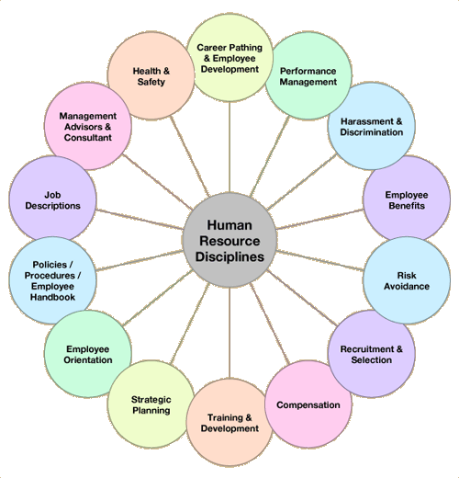

Figure 1: Human Resources Functions. Adapted from Delark HR Solutions (January 2017)

2)

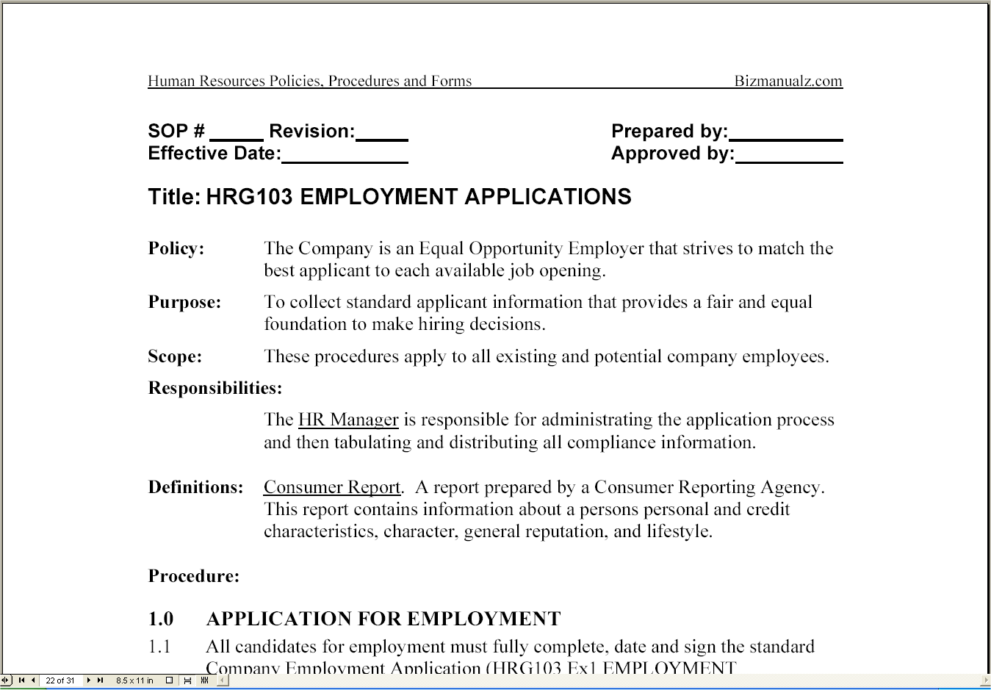

Figure 2: Sample of Human Resource Policy. Adapted from The Business Software Source. (2014)

3)

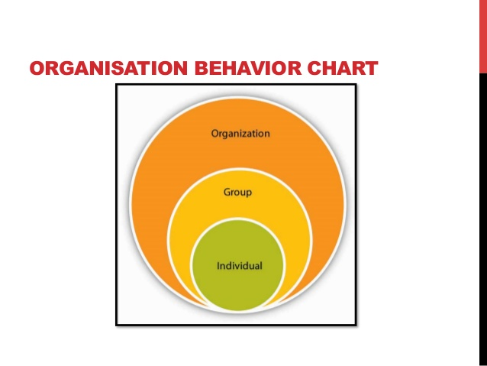

Figure 3: The Organization Behavior. Adapted from Slide share (2015)